# SRW_Sirepo User Manual

# Beamline elements

1. Mirrors:

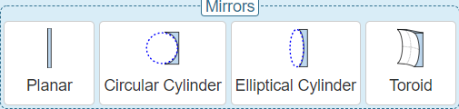

1. Planar Mirror:

Orientation of Reflection Plane: x (Horizontal), y(Vertical)

Grazing Angle [mrad]: the angle between input optical axis and mirror/grating plane

Horizontal Transverse Size [mm]: horizontal transverse size of the output transmission optical element

1. Circular Cylinder, Elliptical Cylinder, Toroid

Geometry setting

Orientation setting

Height Profile